Stage A UML Diagrams

Use Case (Implemented / Planned / Backlog)
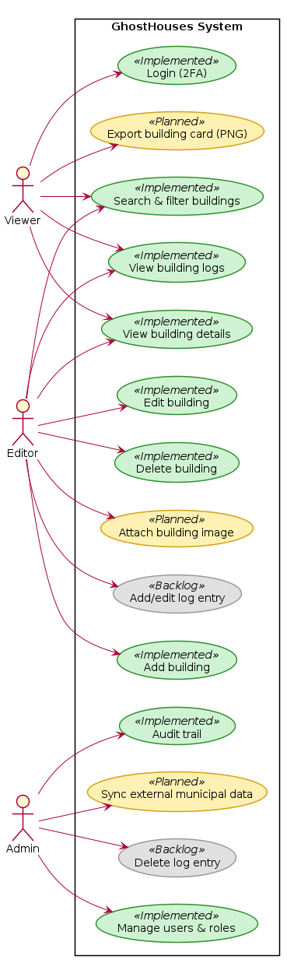

Class Diagram (Implementation vs Planned)
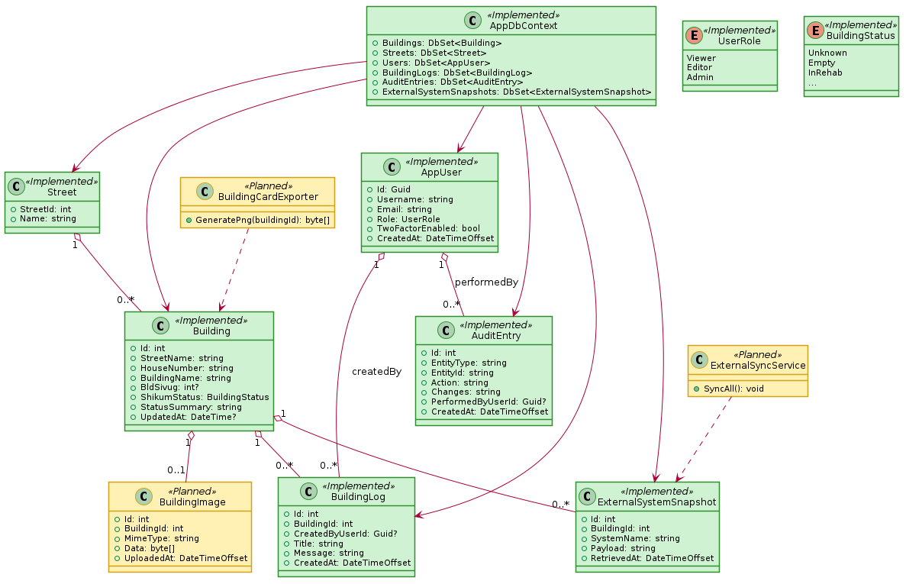

Deployment - Desired
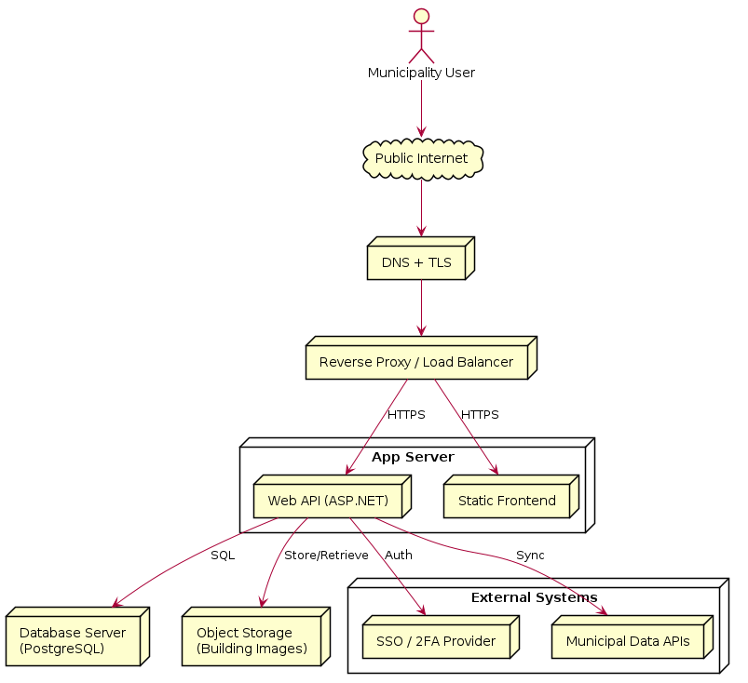

Deployment - Current
